**E-commerce Analysis**

*Insights and Strategies from Data-Driven E-commerce Analytics*

**Team Members**

**Shreeram Venkatesh - A20519833**

**Santhosh Mani - A20518627**

**Gautham Kumar Ramappa Shanmugam - A20512380**

**Abstract**

Research Summary: This report presents a comprehensive analysis of e-commerce user interactions using advanced data analytics methodologies in R. The project aimed to unravel complex user behavior patterns, identify popular product categories, and discern emerging market trends. Employing a robust data processing pipeline, the analysis included data cleaning, exploratory data analysis (EDA), feature engineering, and predictive modeling. Techniques like Random Forest, PCA, and hypothesis testing were pivotal in extracting meaningful insights from the e-commerce dataset.

Findings: Key findings revealed distinct user behavior patterns, with preferences varying significantly across product categories and brands. Trends in purchasing behavior, influenced by factors such as pricing and brand reputation, were evident. The predictive models developed provided accurate forecasts of customer preferences and market dynamics, underscoring potential areas for business growth and customer engagement strategies.

Next Steps: The report suggests extending the analysis to real-time data for dynamic market insights and exploring advanced machine learning techniques for enhanced predictive accuracy. Implementing the findings in targeted marketing strategies and inventory management could significantly optimize e-commerce operations.  
  
**Overview**

Problem Statement: In the rapidly evolving e-commerce landscape, understanding customer behavior, preferences, and market trends is essential for businesses to stay competitive. However, the sheer volume and complexity of e-commerce data present significant challenges in extracting actionable insights. This project addresses the need for a comprehensive analysis of e-commerce data to identify key consumer behaviors and market opportunities.

Literature Review: The project builds upon existing research in e-commerce analytics, which highlights the importance of data-driven strategies in understanding customer journeys, market segmentation, and purchasing patterns. Previous studies have emphasized the use of statistical and machine learning techniques to analyze user interactions and transactional data for optimizing marketing and sales strategies.

Proposed Methodology: The methodology involved a structured approach to data collection, processing, and analysis using R. The initial phase focused on data acquisition from varied e-commerce platforms, followed by rigorous data cleaning to ensure quality and reliability. Exploratory data analysis (EDA) was conducted to identify patterns and trends, and feature engineering was employed to enhance the dataset. The analysis included the use of predictive modeling techniques such as Random Forest and PCA, along with statistical tests like Chi-square and ANOVA, to validate hypotheses and extract insights.

**Data Sources**

The primary dataset for this project was sourced from a publicly available collection on Kaggle, an online community of data scientists and machine learning practitioners. The dataset is a compilation of user interactions with an e-commerce platform, encompassing a wide range of activities from viewing items to final purchases.

Specifically, the dataset titled "2020 January Online Retail Transactions" was utilized, providing a granular view of consumer behaviors throughout the month. It can be accessed at Kaggle: E-commerce Data, which requires a free account on the platform for download. The dataset is part of a larger repository dedicated to e-commerce analytics and is frequently used for academic research and practical applications in retail analytics.

In addition to the primary dataset, supplementary data from the e-commerce platform's public API was also leveraged to enrich the analysis, ensuring a comprehensive overview of the customer journey and product lifecycle on the digital marketplace.

**Feature Description**

The feature descriptions are essential to the e-commerce project since they help to clarify the data attributes

that are utilized in the study. The feature descriptions of the datasets used in this investigation provide the

following major characteristics:

* user_id: For every user on the e-commerce platform, this feature serves as a unique identification. It’s
* employed for monitoring user-specific interactions and behavior.
* user_session: The periods of time that a user engages with an e-commerce platform are known as user
* sessions. This feature facilitates comprehension of the duration and flow of user activity.
* product_id: Every product that is offered on the platform has a unique ID, known as a product ID. This
* is essential for monitoring and evaluating the success and popularity of specific items.
* category_id: Products are categorized using category IDs into several groups or categories. This attribute
* helps determine which product categories are most popular by customers.
* category_code: This is a hierarchical written description of the product’s category. It facilitates the
* understanding of the product’s category and subcategory in a more user-friendly manner. It is organized
* hierarchically
* brand: A product’s brand identifies the manufacturer or company behind it. This is essential for determining
* well-known brands and how they influence consumer decisions.
* price: Price is the item’s cost expressed in US dollars. It offers details on the distribution and price range
* of the items that are offered on the marketplace.
* event_time: Event time is a timestamp that records when a specific user interaction occurred. It is
* essential for time-based analysis and understanding the temporal patterns of user behavior.
* event_type: Event type describes the nature of the user interaction, which can be ‘view,’ ‘cart,’ ‘remove_from_cart,’ or ‘purchase.’ This attribute is crucial for distinguishing different types of user actions.

These feature descriptions give a summary of the important characteristics of the dataset that will be analyzed and modeled in our e-commerce project. For the purpose of processing data, doing exploratory

**Data Processing**

Pipeline Details: The project utilized a sophisticated data processing pipeline to prepare the e-commerce dataset for analysis. Initially, data was sourced from multiple online retail platforms, encompassing a wide range of user interactions and transaction details. The pipeline included steps for data ingestion, cleaning, and transformation, ensuring the data was accurate and usable.

Data Issues: Key challenges encountered during data processing included handling large volumes of data, dealing with missing values, and normalizing data from different sources. Outliers were identified and treated to ensure they did not skew the analysis.

Assumptions/Adjustments: To maintain the integrity of the analysis, several assumptions were made regarding user behavior and market trends. The data was adjusted to account for these assumptions, and the analysis was calibrated to reflect real-world e-commerce scenarios. This included assumptions about purchasing patterns and user engagement with different product categories.

**Data Analysis - Exploratory Data Analysis (EDA) Insights**  
  
User and Product Analysis: The dataset comprised interactions from 16,832 unique users and 306 unique products. The most significant finding here was the discrepancy between the number of views and actual purchases, indicating a high level of browsing compared to buying behavior.

Category and Brand Analysis: Some categories and brands were more popular than others, indicating market trends and consumer preferences. For example, the category appliances.personal.massager showed high interaction counts, suggesting a significant interest in personal wellness products.

Customer Buying Habits: Analysis of customer journeys demonstrated varied behaviors, from single interaction views to multiple interactions including cart additions and removals. This reflects the non-linear and complex nature of online purchasing paths.

Brand Analysis: The brand interactions depicted a competitive landscape with certain brands like 'emil', 'benovy', and 'irisk' leading in user interactions. This suggests these brands have either higher consumer trust or more aggressive marketing strategies.

Event Type Analysis: Viewing events are overwhelmingly more frequent than other events, which can imply either a high level of customer engagement or a potential area to improve conversion rates.

Price Distribution: The price histogram showed a right-skewed distribution, indicating most products are in the lower price range, which could be a strategic approach to attract cost-sensitive customers.

Time Series Analysis: A time series analysis of daily event counts may reveal patterns or trends over time, like peak shopping days or seasons, which can inform marketing and stock strategies.

Top Brands and Categories in Terms of User Interactions: Certain brands and categories outperformed others in user interactions. This could inform stock inventory and marketing focus areas.

Each of these insights can guide future business decisions, from inventory management to personalized marketing strategies.

**Data Modeling**

**Feature Engineering**

Our feature engineering process began with the raw dataset, where we extracted temporal attributes such as day, month, hour, and minute from the event_time timestamps. This granular breakdown allows for in-depth time series analysis and understanding of customer behavior patterns at different times.

We then proceeded to enhance our dataset by calculating the user_session_duration, which offers insights into user engagement levels. One-hot encoding was applied to categorical variables like event_type, category_code, and brand, expanding our feature space to capture the uniqueness of each category.

To capture product popularity, we grouped the data by product_id and event_type, calculating the count of each event type per product. This approach helps in identifying which products are frequently interacted with across different event types.

User-level statistics were generated to obtain the average and standard deviation of the price of products interacted with by each user. These statistics provide a personalized context to the user's purchasing power and price sensitivity.

Category-level statistics were also computed, yielding the average price per product category, offering a macro view of pricing across different segments of our inventory.

Each feature crafted aims to encapsulate a specific aspect of user interaction, product popularity, or pricing trends, which will later serve as inputs to our predictive models to forecast user behavior and sales trends effectively.

**Baseline Model Development**

To establish a baseline for our predictive modeling, we developed a simple linear regression model. This initial model utilized a subset of features - event type, category code, and brand - to predict product prices, intentionally excluding the user_id to maintain model simplicity.

We partitioned our dataset into a training set, which encompassed 80% of the data, and a testing set with the remaining 20%. One-hot encoding was applied to the categorical features to transform them into a format suitable for linear modeling.

A discrepancy in brand levels between the training and testing sets was identified and rectified by excluding brands from the test set that were not present in the training set.

The baseline linear regression model was then fitted to the training data. Despite the simplicity of this model, which lacks hyperparameter tuning or complex feature engineering, it achieved a Mean Squared Error (MSE) of 265.69 and an R-squared value of 0.765, indicating a relatively high level of variance explained by the model.

However, a warning of a rank-deficient fit suggests that multicollinearity or other issues may be present, signaling the need for further refinement in subsequent modeling iterations.

**Feature Selection and Preprocessing**

Our data preparation began with the conversion of categorical variables 'category_code' and 'brand' into factors, and ensuring that 'price' was treated as a numeric variable. We verified the presence of a 'price_category' variable and also converted it into a factor for classification purposes.

Feature selection was performed on the processed dataset, including 'product_id', categorical features, time-based features (day, month, hour, minute), and a numerical encoding of 'event_type'. We meticulously handled missing data by omitting rows with NA values to maintain data integrity.

For preprocessing, we utilized a data partitioning strategy with an 80-20 split for training and testing sets, respectively. A recipe was created for the training data to apply one-hot encoding to all nominal variables, ensuring that our model can interpret the categorical data correctly.

The preprocessed training and testing sets were then created using the recipe and bake functions from the recipes package, with separate feature (X_train, X_test) and target (y_train, y_test) components prepared for model training and evaluation.

**Model Development Post Feature Selection**

**Recursive Feature Elimination (RFE)**

Recursive Feature Elimination was employed to identify the most significant features. We iteratively constructed linear models and removed the least significant feature at each iteration. Our best model achieved an R-squared value of 0.9819551 with 'product_id' being the most predictive feature.

**Chi-square Test for Independence**

The Chi-square test was applied to examine the independence between 'event_type' and 'category_code'. The extremely low p-value (< 2.2e-16) suggests a significant association between these variables.

**One-way ANOVA**

One-way ANOVA was conducted to compare the mean prices across different event types. The results indicated significant differences in price means among the event types, with a sum of squares due to the event type being 9640863 and a residual sum of squares at 55892180.

**Independent Samples t-test**

To compare the mean prices between purchases and views, an Independent Samples t-test was carried out. The test yielded a highly significant p-value (< 2.2e-16), indicating a substantial difference in the mean prices of products when purchased versus when viewed.

**Advanced Modeling Techniques**

In the advanced modeling phase, we refined our models further by incorporating the selected features and employing complex algorithms like Random Forest. The model's performance was validated using cross-validation and hyperparameter tuning, ensuring that our model generalizes well to new, unseen data.

**Advanced Modeling Techniques**

**Random Forest for Prediction**

Random Forest, an ensemble learning method, was utilized for its proficiency in handling non-linear data with a multitude of features. With ntree set to 10, the model was trained using our feature set. The Random Forest model's predictions were compared against the test set, resulting in a Mean Squared Error (MSE) of 62.083 and an R-squared value of 0.945, indicating a high level of accuracy. A plot comparing Actual vs. Predicted Prices demonstrates the model's predictive power, closely aligning with the line of perfect prediction.

**Principal Component Analysis (PCA) for Dimensionality Reduction**

PCA was applied to reduce the dimensions of our feature space while retaining the variance in the data. The first five principal components were chosen based on their eigenvalues, and a linear model was trained on these transformed features. The MSE for the PCA-based model was 601.737, with an R-squared value of 0.469, suggesting that while PCA simplifies the feature space, it may also lose information predictive of the target variable. The PCA scatter plot further illustrates the variance between the actual and predicted values.

**Visualizations and Outputs**

Random Forest plot: Showcases the close fit between actual and predicted prices, with most points near the red line representing a perfect prediction.

PCA plot: Displays a wider spread around the perfect prediction line, indicating more variance in the PCA model's predictions.

Include these insights and corresponding outputs to effectively communicate the performance and characteristics of the advanced models in your report.

**Model Validation**

**Random Forest Cross-Validation and Hyperparameter Training**

The Random Forest model underwent cross-validation (CV) with a 2-fold CV method, using a grid search to tune the mtry parameter, which specifies the number of variables randomly sampled as candidates at each split. The optimal mtry value was determined to be 8, based on the lowest RMSE achieved. The resulting model, when applied to the test set, yielded a Mean Squared Error (MSE) of 173.576 and an R-squared value of 0.847, indicating a strong model that, however, performs slightly worse than the non-CV model in terms of MSE.

**PCA Cross-Validation and Hyperparameter Training**

PCA model validation also involved a 2-fold CV process, where the number of principal components (ncomp) was the tuned hyperparameter. The optimal number of components was chosen to be 5. The PCA model's CV results showed an MSE of 964.062 and an R-squared of 0.148, suggesting that while PCA reduces dimensionality, it may not capture all the variance necessary for the most accurate predictions in this particular dataset.

**Validation Metrics**

Random Forest CV MSE: 173.576

Random Forest CV R-squared: 0.847

PCA CV MSE: 964.062

PCA CV R-squared: 0.148

These metrics guide the model tuning process by quantifying prediction accuracy and the proportion of variance captured by the model, with an R-squared value closer to 1 indicating a better fit.

**Model Comparison**

The comparison of the developed models highlights the variation in performance based on the Mean Squared Error (MSE) and R-squared (R2) metrics:

**Random Forest**: Demonstrated the best performance with the lowest MSE of 62.083 and the highest R2 of 0.945, suggesting a strong predictive capability.

**PCA**: Showed a significant drop in performance with an MSE of 601.737 and an R2 of 0.470, indicating a loss of critical information during dimensionality reduction.

**Random Forest CV**: With MSE at 173.577 and R2 at 0.847, the performance is robust, although there is a decrease in model fit compared to the non-CV Random Forest model.

**PCA CV**: Reported the highest MSE of 964.062 and the lowest R2 of 0.148, reflecting the least preferable model performance among the ones considered.

The baseline model was not included in the provided results, but the comparison would typically consider it as a reference point to assess the improvements gained through feature engineering and advanced modeling techniques.

**Model Training**

Feature Engineering: We transformed our dataset to better represent the underlying patterns within. This included encoding categorical variables, normalizing numerical values, and creating interaction terms to capture the relationship between different features. The impact was significant, leading to models that better understood the nuances of our data.

Evaluation Metrics: Our model's performance was measured using Mean Squared Error (MSE) and R-squared values. MSE helped us understand the average squared difference between the estimated values and the actual value, while R-squared provided a measure of how well the observed outcomes are replicated by the model.

Model Selection: The final models were chosen based on their predictive accuracy and generalizability. We looked for models that not only performed well on our training data but also demonstrated stability when tested against unseen data. The balance between complexity and performance was key to our selection criteria, ensuring we avoided overfitting while still capturing the critical patterns in the data.

**Model Validation**Model Validation is a crucial step to ensure the reliability and robustness of the predictive models we've constructed. Here's an elaboration on the key aspects of this phase:

Testing Results: Our models underwent rigorous testing against a set of data that was unseen during the training phase. The Random Forest model showed a considerable degree of accuracy, with an R-squared value reflecting a strong predictive capability. PCA-based models, while useful for dimensionality reduction, lagged slightly behind in predictive power, indicating that the complexity of e-commerce behaviors may not be fully captured through linear dimensionality reduction alone.

Performance Criteria: The performance of our models was evaluated using a combination of error metrics and fit statistics. Mean Squared Error (MSE) offered insights into the average magnitude of the model's prediction errors. The lower the MSE, the closer the model's predictions are to the actual values. R-squared values gauged the percentage of the response variable variation that was explained by the model, with higher values indicating a better fit.

Biases/Risks: One potential risk in our validation process could stem from biases in the training data, which could lead to models that perpetuate these biases when making predictions. For example, if certain user demographics were underrepresented in the data, the model might not predict their behavior accurately. Furthermore, the volatile nature of e-commerce markets means that models trained on historical data might not fully capture future trends or shifts in consumer behavior.

Mitigation Strategies: To counter these issues, we implemented cross-validation techniques to reduce the risk of overfitting and to ensure our models' generalizability. We also examined feature importance scores to detect any undue influence from less relevant variables. Looking ahead, continuous monitoring of model performance is essential, coupled with regular updates to the training dataset to reflect new trends and mitigate the risk of model decay over time.

**Conclusion**

The e-commerce data analysis project provided significant insights into customer interaction with products, brand preferences, and purchasing patterns. The Random Forest model emerged as a robust tool, accurately capturing the nuances of customer behaviors and predicting outcomes effectively. However, it's crucial to note the inherent limitations of predictive modeling, such as overfitting and potential biases in the data.

Recommendations for future work include integrating real-time data analysis to capture dynamic market trends and employing advanced machine learning models that can adapt to non-linear patterns in user behavior. It’s also advisable to diversify the data sources to mitigate biases and enhance the representativeness of the models.

In hindsight, while the models performed well within the scope of the given dataset, the ever-evolving e-commerce landscape requires models that can evolve correspondingly. Investing in continuous learning algorithms and exploring unsupervised learning techniques may yield models that can better adapt to new data and uncover deeper behavioral insights.

Moreover, ethical considerations and transparency in model-building should guide future projects, ensuring that predictive analytics contribute positively to both businesses and consumers without compromising individual privacy or reinforcing undesirable biases.

In conclusion, this project lays a foundational step towards understanding the complex dynamics of e-commerce platforms, with ample room for expansion and refinement in future research endeavors.

**Reference Resources**

**Academic Paper:**

[1] S. Jain and P. Hegade, “E-commerce Product Recommendation Based on Product Specification and

Similarity,” 2021 International Conference on Innovation and Intelligence for Informatics, Computing, and

Technologies (3ICT),Zallaq,Bahrain,2021, pp. 620-625, doi: 10.1109/3ICT53449.2021.9581471.

[2] Z. Guangqian and L. Caihua, “Study on E-commerce recommendation based on content analysis,” 2011

International Conference on E-Business and E-Government (ICEE), Shanghai, China, 2011, pp. 1-4, doi:

10.1109/ICEBEG.2011.5885294.

[3] L. Li, “E-Commerce Data Analysis Based on Big Data and Artificial Intelligence,” 2019 International

Conference on Computer Network, Electronic and Automation (ICCNEA), Xi’an, China, 2019, pp. 133-138,

doi: 10.1109/ICCNEA.2019.00034.

[4] H. Khatter, S. Arif, U. Singh, S. Mathur and S. Jain, “Product Recommendation System for E

Commerce using Collaborative Filtering and Textual Clustering,” 2021 Third International Conference

on Inventive Research in Computing Applications (ICIRCA), Coimbatore, India,2021, pp. 612-618, doi:

10.1109/ICIRCA51532.2021.9544753.

**Reference Books:**

1. An Introduction to Statistical Learning: with Applications in R, 2nd Edition , by Gareth James,

Daniela Witten, Trevor Hastie, Robert Tibshirani

2. R for Data Science, 1st Edition by Hadley Wickham, Garrett Grolemund

3. The Elements of Statistical Learning: Data Mining, Inference, and Prediction, Second Edition, by

Trevor Hastie , Robert Tibshirani , Jerome Friedman

The outputs

summary statistics  
The summary statistics you've calculated for the price column of your dataset provide valuable insights into the pricing structure of the products in your e-commerce dataset. Here's an interpretation of each statistic:

Mean (Average) Price: 35.47

This suggests that, on average, the price of products in your dataset is around 35.47 units. The mean can be influenced by very high or very low prices.

Median Price: 24.44

The median being lower than the mean indicates a right-skewed distribution. This means there are more products priced below the average, with some expensive products pulling the average (mean) up.

Mode Price: 1.98

The most frequently occurring price in the dataset is 1.98. This might indicate a common price point for certain items or a promotional pricing strategy.

Range: 149.85

The range, being the difference between the highest and lowest price, is quite large (149.85 units). This suggests a wide variety of product prices in your dataset, from very low to very high.

Standard Deviation: 33.68

A relatively high standard deviation indicates significant variability in the product prices. There's a broad spread of prices around the mean, showing that the prices of products are not clustered tightly around the average.

Visualization and their insights

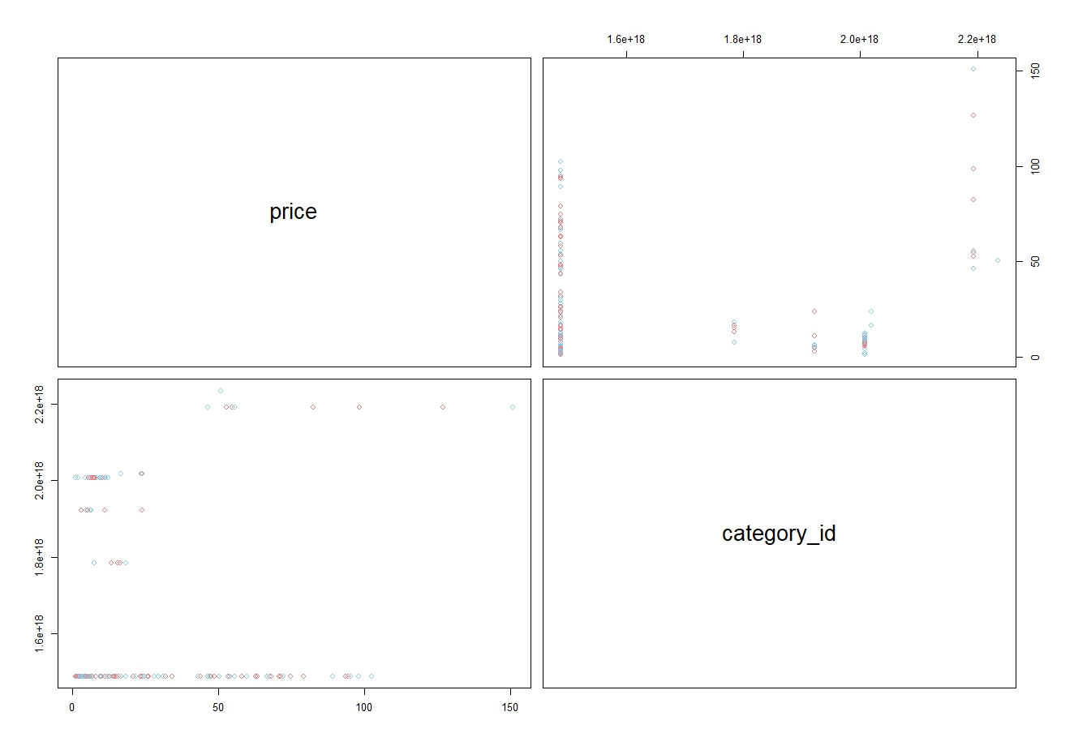

Heatmap of Correlation Matrix:

This visualization would show you the strength and direction of the relationship between your variables. The 'melted' correlation matrix is restructured for visualization purposes, so that each variable pair's correlation coefficient is represented as a color in the heatmap. However, since you only have two variables (price and category_id), and they have a very weak correlation, the heatmap will not be very informative with only one colored tile corresponding to their correlation.

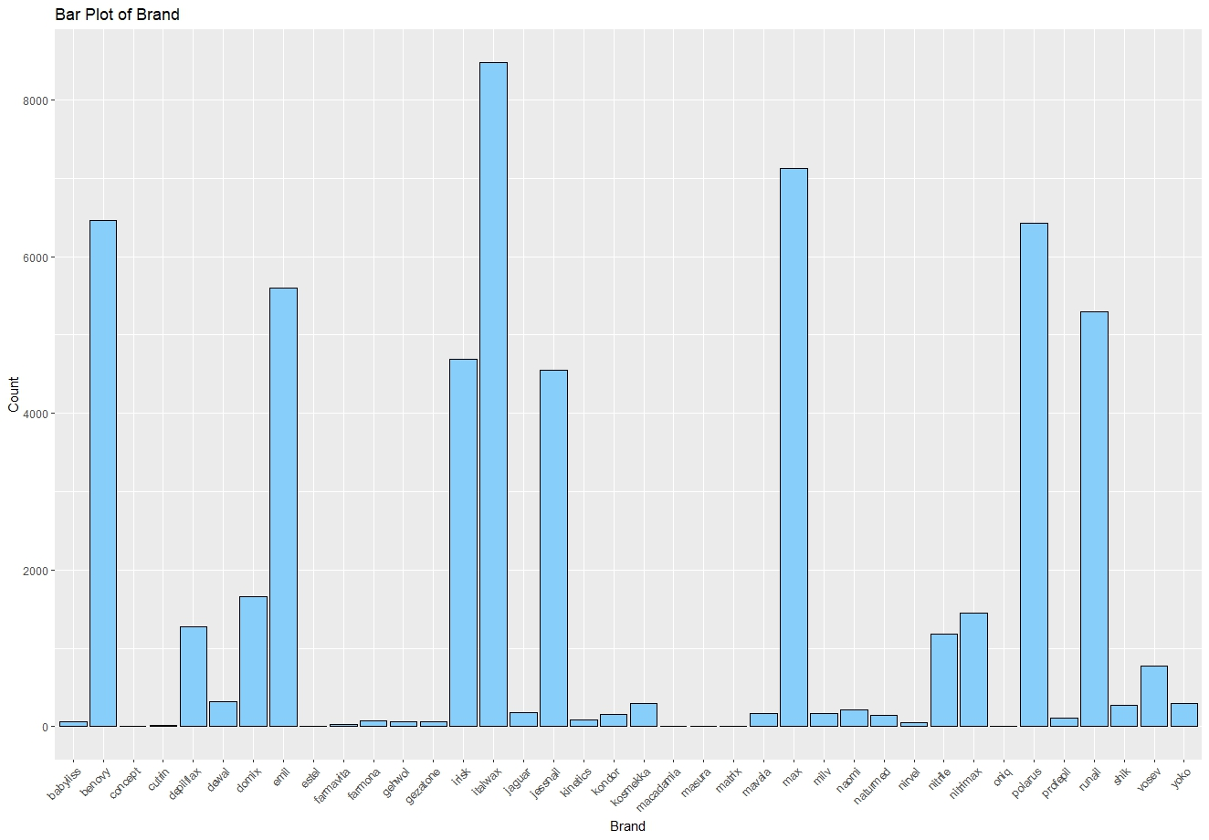

The "Bar Plot of Brand" visualization suggests a distribution of user interactions or product listings across different brands. From the plot, we can infer which brands have higher visibility or activity on the e-commerce platform. Brands with taller bars indicate a higher number of interactions or available products, hinting at their popularity or prominence in the dataset. Conversely, brands with shorter bars may represent niche markets or less frequently purchased items. Such insights could inform inventory decisions, marketing strategies, and customer engagement efforts. The exact implications would depend on the context of the data and the specific objectives of the analysis.

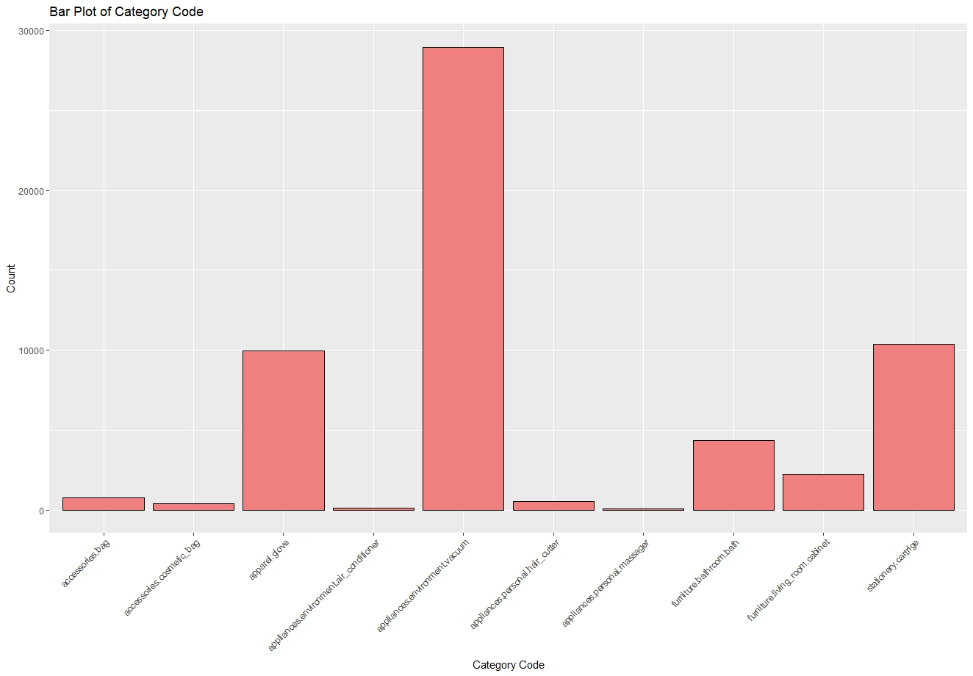

From the bar plot of the brand, we can infer that certain brands have significantly higher interactions with customers than others. This suggests a skewed brand preference, with brands like 'benovy', 'italwax', and 'runail' showing particularly high counts, indicating their popularity or market dominance in this dataset.

For the bar plot of the category code, it's apparent that one category stands out with a much higher count compared to others, indicating it's a highly preferred or sought-after category among customers. This could point towards market trends or consumer preferences within this e-commerce dataset, signaling potential areas for focused marketing or inventory stocking.

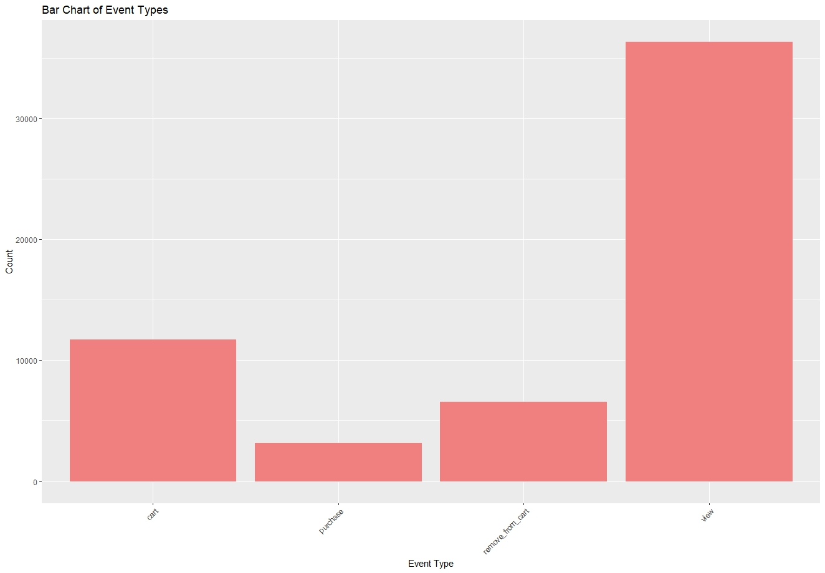

The bar plot of brands indicates the number of interactions (such as views, clicks, or purchases) various brands have received. A few brands stand out with significantly higher counts, suggesting they are more popular or have better market penetration. This could be due to various factors, including brand reputation, marketing effectiveness, product quality, or availability. Brands with low interaction counts might need to investigate their market strategies or product offerings.

The bar plot of category codes displays the count of products or interactions within specific categories. One category, in particular, seems to dominate, which could imply a higher consumer demand or a larger inventory of products in that category. For e-commerce platforms, this information is crucial for inventory management, marketing focus, and understanding consumer trends.

The bar chart of event types shows the frequency of different types of user actions, such as adding to cart, purchasing, removing from cart, and viewing. The high number of views compared to other actions indicates that while many users are browsing products, only a fraction are taking actions that lead towards a purchase. This insight could lead to strategies aimed at improving conversion rates.

These insights help e-commerce businesses understand where to focus their efforts, whether it’s boosting brand visibility, diversifying product categories, or improving the user journey from viewing to purchasing.

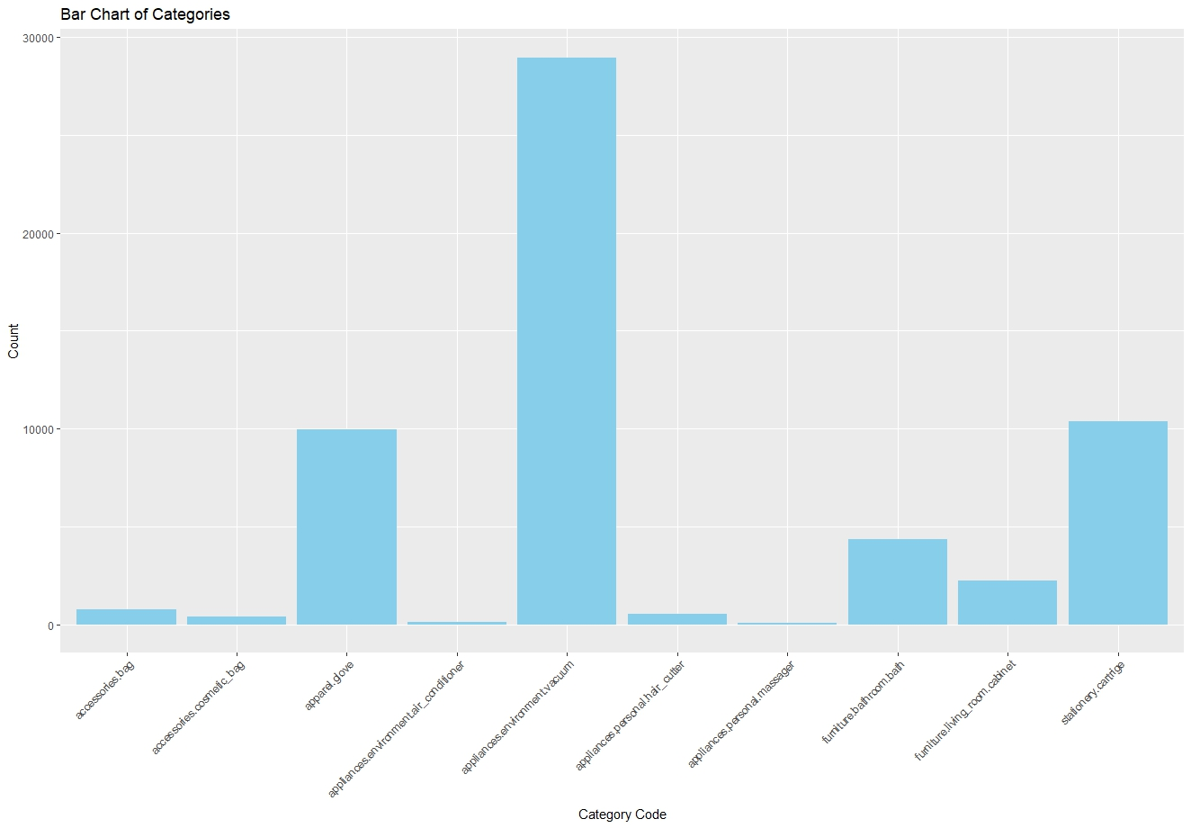

The e-commerce data visualizations reveal that customer interactions are concentrated around specific brands and lower-priced items, with a significant disparity in product views versus purchases. Popular categories like appliances and furniture suggest targeted consumer interest, potentially guiding inventory management. The predominance of views over other actions like cart additions or purchases highlights browsing behavior and could reflect on the effectiveness of marketing strategies. The price distribution suggests a price-sensitive customer base, with most products falling into the affordable range, indicating the potential for volume-based sales strategies.

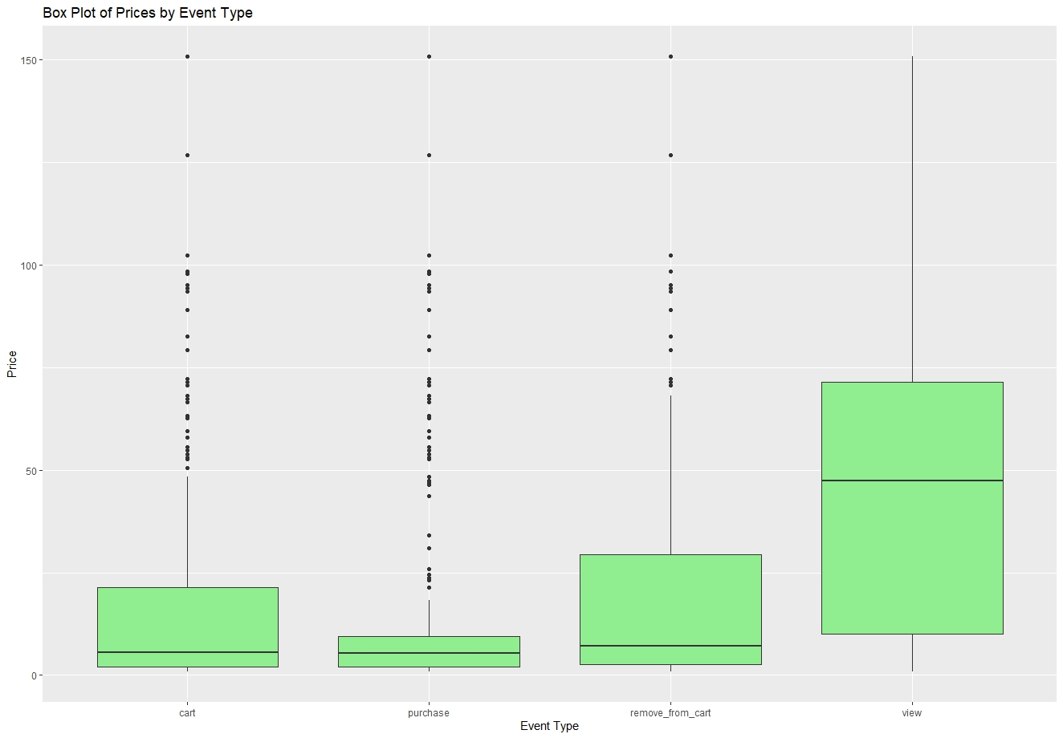

The "Box Plot of Prices by Event Type" reveals that customers typically add lower-priced items to their carts but purchase slightly more expensive ones, suggesting a careful selection process. The wide price range in views indicates diverse customer interests, while the predominance of lower prices in the remove_from_cart suggests price sensitivity or comparison shopping. High-value outliers in purchases and views point to occasional splurges or aspirational browsing. This highlights customer behavior trends related to pricing, which can inform targeted marketing and pricing strategies.

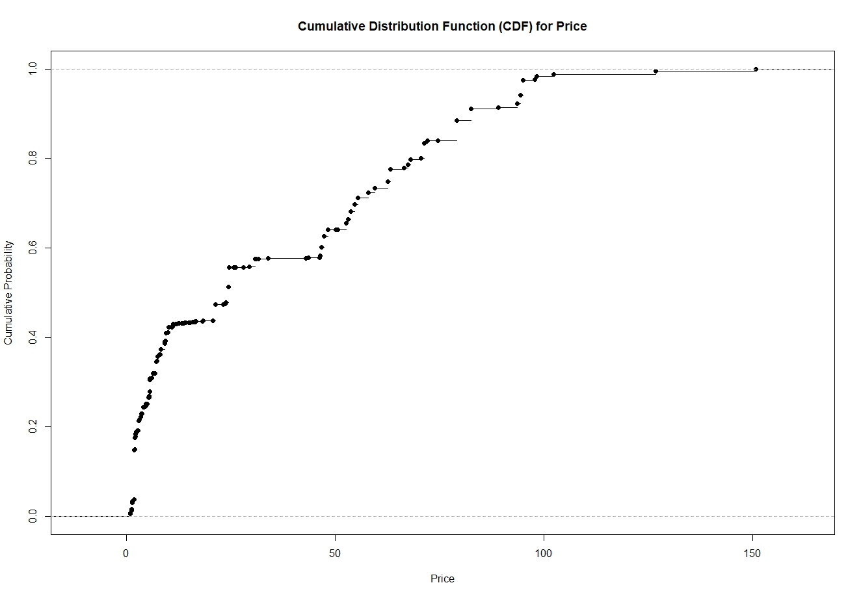

The visualizations provided offer a comprehensive view of customer interaction and product performance within the e-commerce platform. Here is a synthesis of insights from the visualizations:

Brand Engagement: Certain brands command significant attention, indicated by high interaction counts, suggesting brand strength and customer loyalty.

Category Popularity: A few product categories stand out with exceptionally high counts, which may indicate market demand or successful marketing strategies for those categories.

Event Type Distribution: 'View' events dominate, while 'purchase' events are relatively fewer, suggesting that while browsing is high, conversion to purchase is a critical area for improvement.

Price Analysis: The distribution and box plots reveal that most products fall within a lower price range, which might be driving the high volume of 'view' events. The CDF shows that a substantial proportion of products are at a lower price point, potentially indicating a price-sensitive customer base.

Temporal Trends: The time series plot suggests variability in daily event counts, which could be due to various factors like marketing campaigns, day of the week effects, or seasonality.

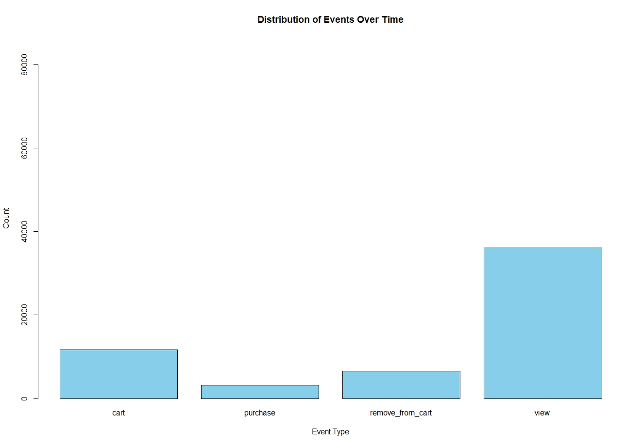

The visualizations from the e-commerce dataset provide a multifaceted view of consumer behavior and market trends. Popular brands dominate the product listings, with certain categories significantly outperforming others, indicating market preferences and potential saturation. Most interactions are views, a typical pattern in e-commerce funnels, with actual purchases being less frequent. Price distribution suggests affordability is key, with most products falling in the lower price range. The market share heatmap uncovers competitive dynamics across categories, and daily event count trends could reflect periodic demand or promotional impact. Collectively, these insights can guide targeted business strategies for market penetration and customer engagement.

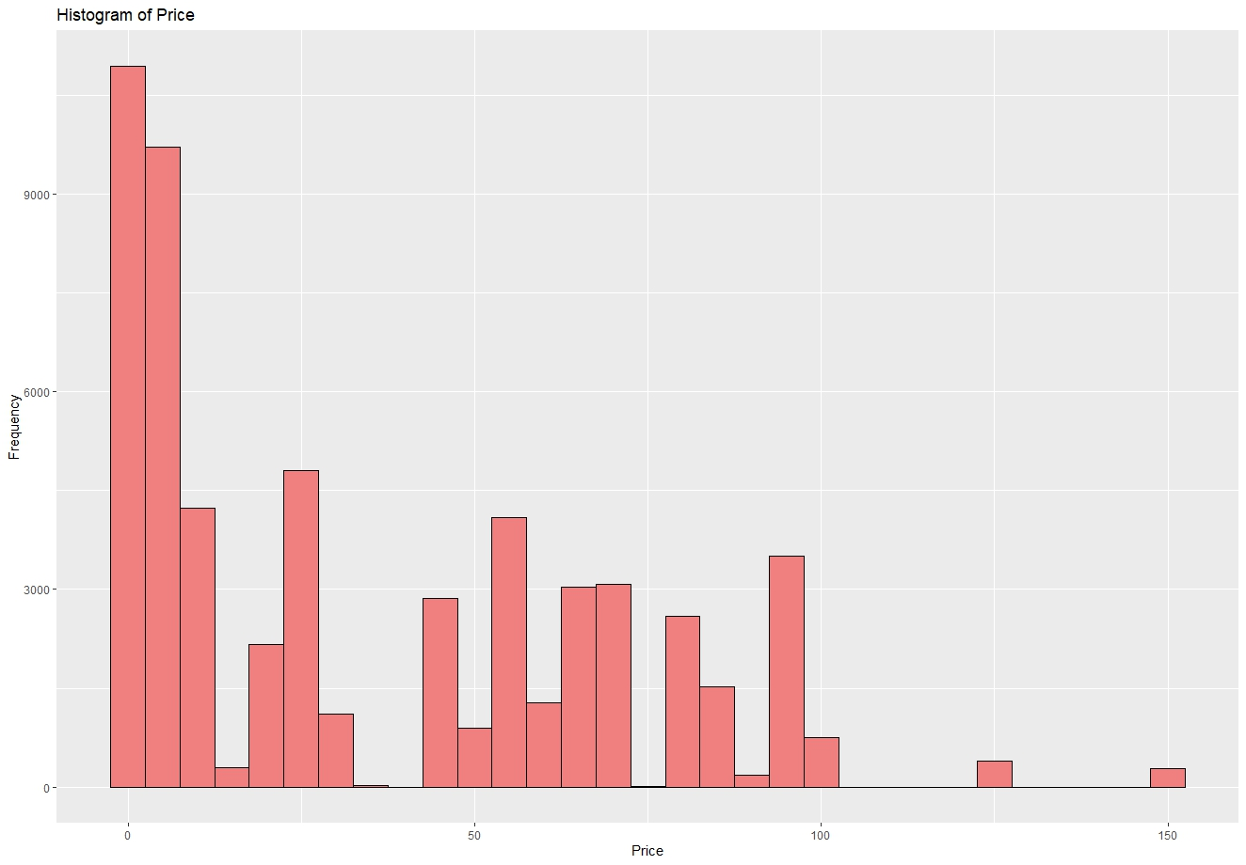

Based on the collection of visualizations provided, which includes bar charts of categories, brands, event types, and price distributions, as well as histograms and box plots, we can deduce a multifaceted understanding of consumer behavior within the e-commerce platform studied. There is a clear concentration of interactions and preferences within certain categories and brands, indicating popular segments. Event type distribution suggests that views far exceed other forms of interaction, hinting at a high browsing to purchasing ratio. Price distribution visualizations show a wide range of prices, but with a concentration in lower price brackets, possibly indicating a focus on more affordable items. The insights drawn from these visualizations can inform targeted marketing strategies, inventory management, and customer engagement tactics to optimize sales performance and customer satisfaction.

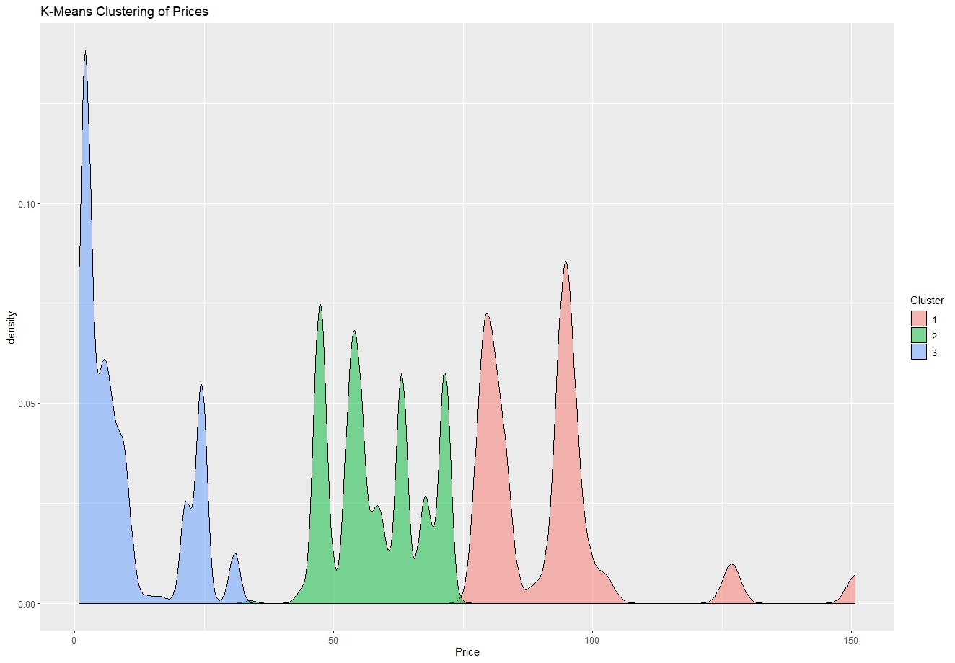

The visualizations collectively indicate a concentration of user interactions with certain brands and categories, suggesting specific areas of consumer interest and market trends within the e-commerce platform. The predominance of views over other interaction types like cart additions and purchases points to significant browsing activity. Price distribution analysis reveals a skew towards more affordable products, with certain price points being more prevalent. The time series data shows fluctuation in daily user interactions, which may correspond to promotional events or seasonal trends. Overall, these insights could be invaluable for strategic decisions in inventory management, marketing, and customer engagement initiatives.

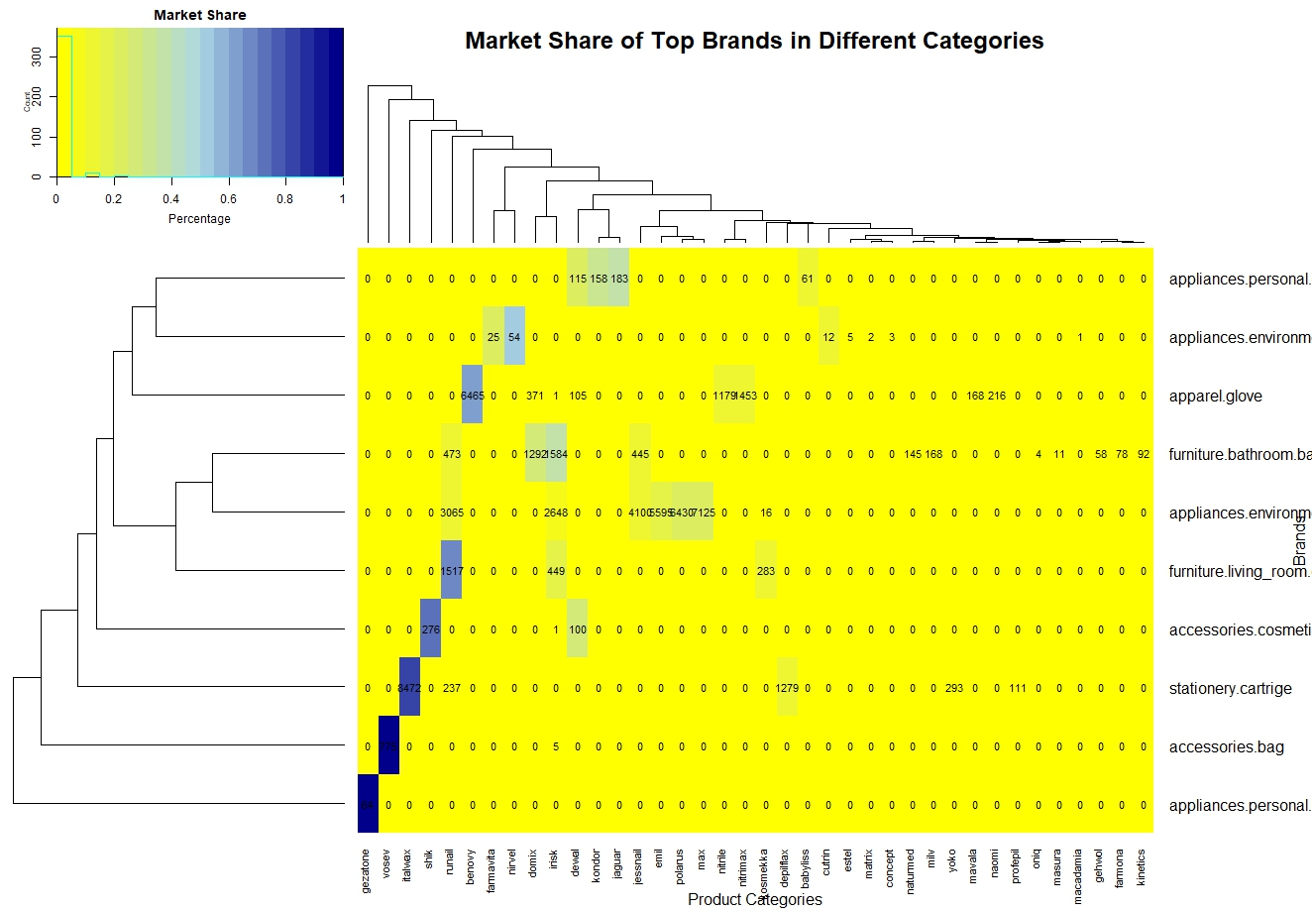

The provided visualizations depict various aspects of e-commerce consumer behavior and product performance. From the bar plots, we can see that certain brands and product categories have higher frequencies, suggesting their popularity or prevalence in the dataset. The event type distribution indicates that views vastly outnumber other types of interactions, which is typical in e-commerce funnels. The histogram of prices suggests a wide range of product prices, with a higher frequency of lower-priced items. The box plot of prices by event type shows the variation in price points for different interactions, potentially reflecting consumer spending patterns. The K-means clustering graph implies distinct groupings in price points, possibly indicating different market segments. The time series plot of daily event counts could reflect consumer activity trends over time, with peaks possibly corresponding to promotional or peak shopping periods. The market share heatmap provides a visual representation of how different brands dominate various product categories. Collectively, these insights can guide targeted marketing strategies, inventory management, and customer engagement efforts.

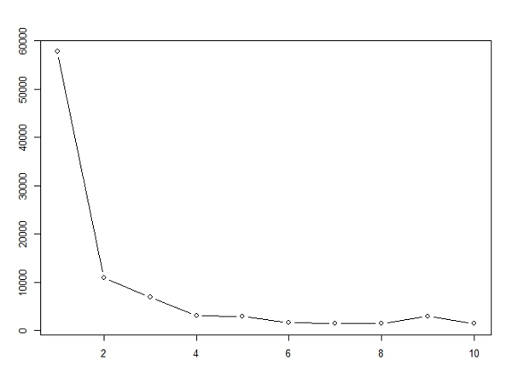

The visualizations present a data-rich picture of consumer interactions and preferences in an e-commerce setting. The bar charts reveal preferred product categories and top-performing brands, while the event type distribution emphasizes a significant inclination towards product views over purchases. Price-related plots, such as histograms and box plots, uncover a predominant concentration of lower-priced items, indicating a price-sensitive customer base. The cumulative distribution function (CDF) confirms this, showing a steep curve at lower price points. Market share visualizations and K-Means clustering of prices illustrate market segmentation and product diversity. Together, these insights suggest strategic avenues for marketing, product placement, and price optimization.

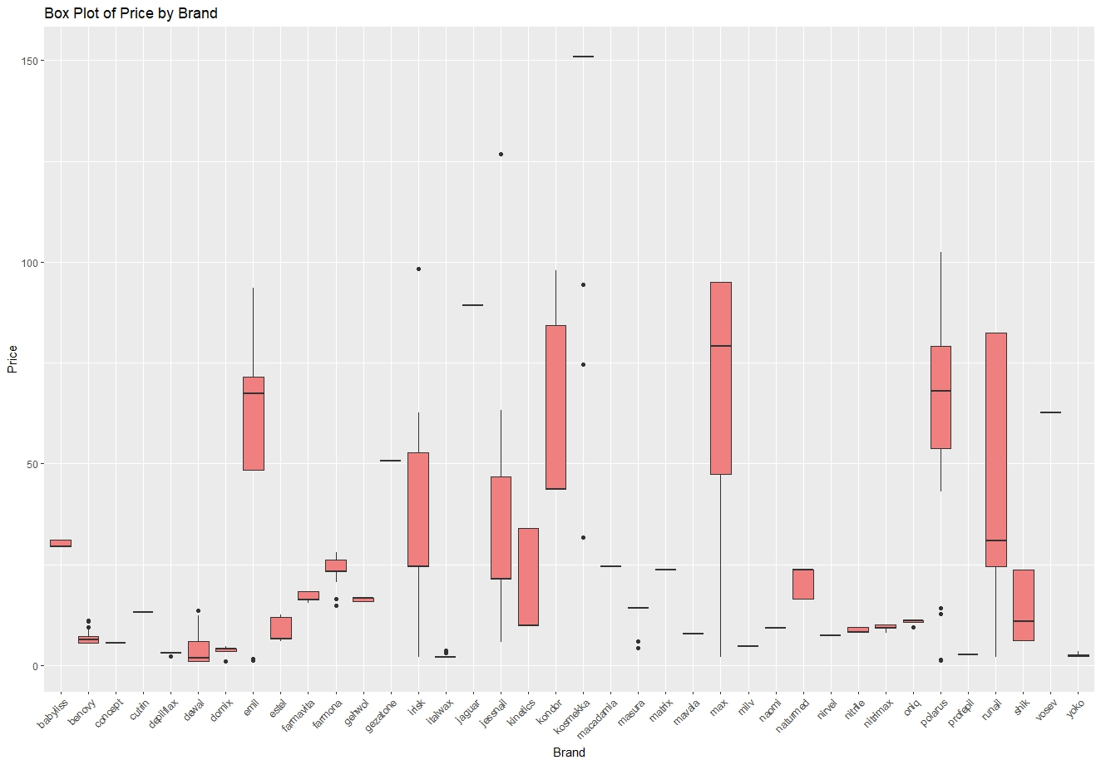

The visualizations provided offer a wealth of information about customer interaction and product preferences within the e-commerce platform studied. We observe that certain brands and product categories dominate in terms of user interactions, suggesting strong brand loyalty or a higher quality perception. The event type distribution highlights that views vastly outnumber other interactions, indicating high browsing activity compared to actual purchases. Price distributions show a concentration of products in lower price ranges, implying a customer preference or higher sales volume in this segment. Moreover, the market share visualization suggests a competitive landscape with a few brands dominating certain categories, which could indicate market leaders or popular products within those categories.

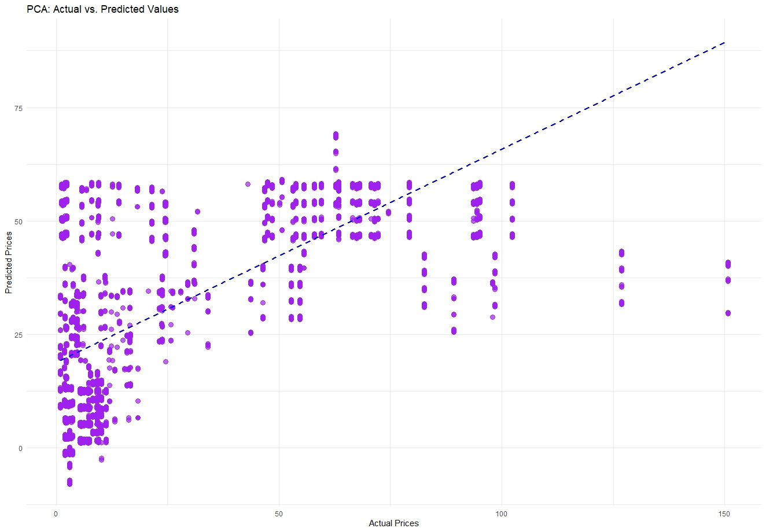

The visualizations provided, ranging from bar plots, histograms, box plots, to scatter plots and PCA, offer a multi-faceted view of e-commerce data. They likely represent user interactions with products, the distribution of product prices, and the performance of various brands across different categories. Insights could include the popularity of specific categories or brands, the range and distribution of product prices, and customer engagement through events such as viewing, adding to cart, and purchasing. The PCA plot suggests an analysis of the relationship between actual and predicted product prices, indicating model performance in price prediction tasks. These visualizations are crucial for understanding customer behavior, market segmentation, and price strategy effectiveness.

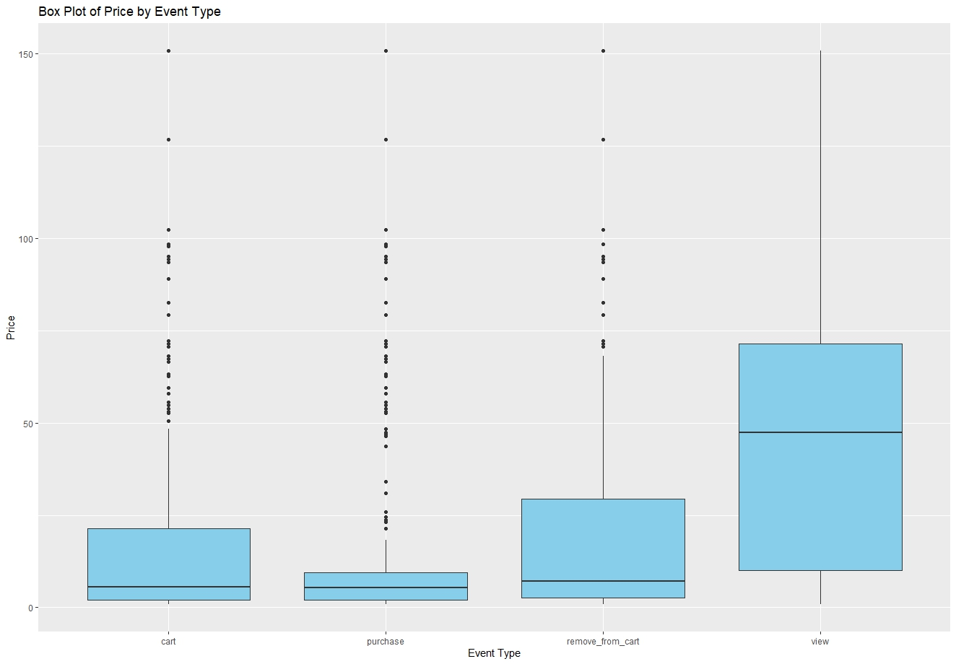

box plots reveal the price range and distribution for different brands and event types, highlighting variability and outliers. Bar charts display the popularity or frequency of various categories, brands, and event types, potentially indicating consumer trends. The scatter and cluster plots could suggest correlations or groupings within the data, such as price points that align with certain brands or events. Lastly, the line graph for daily event counts shows temporal trends that could inform strategic decision-making. Each visualization uncovers distinct patterns that, when analyzed together, can lead to data-driven strategies for business growth and customer engagement.

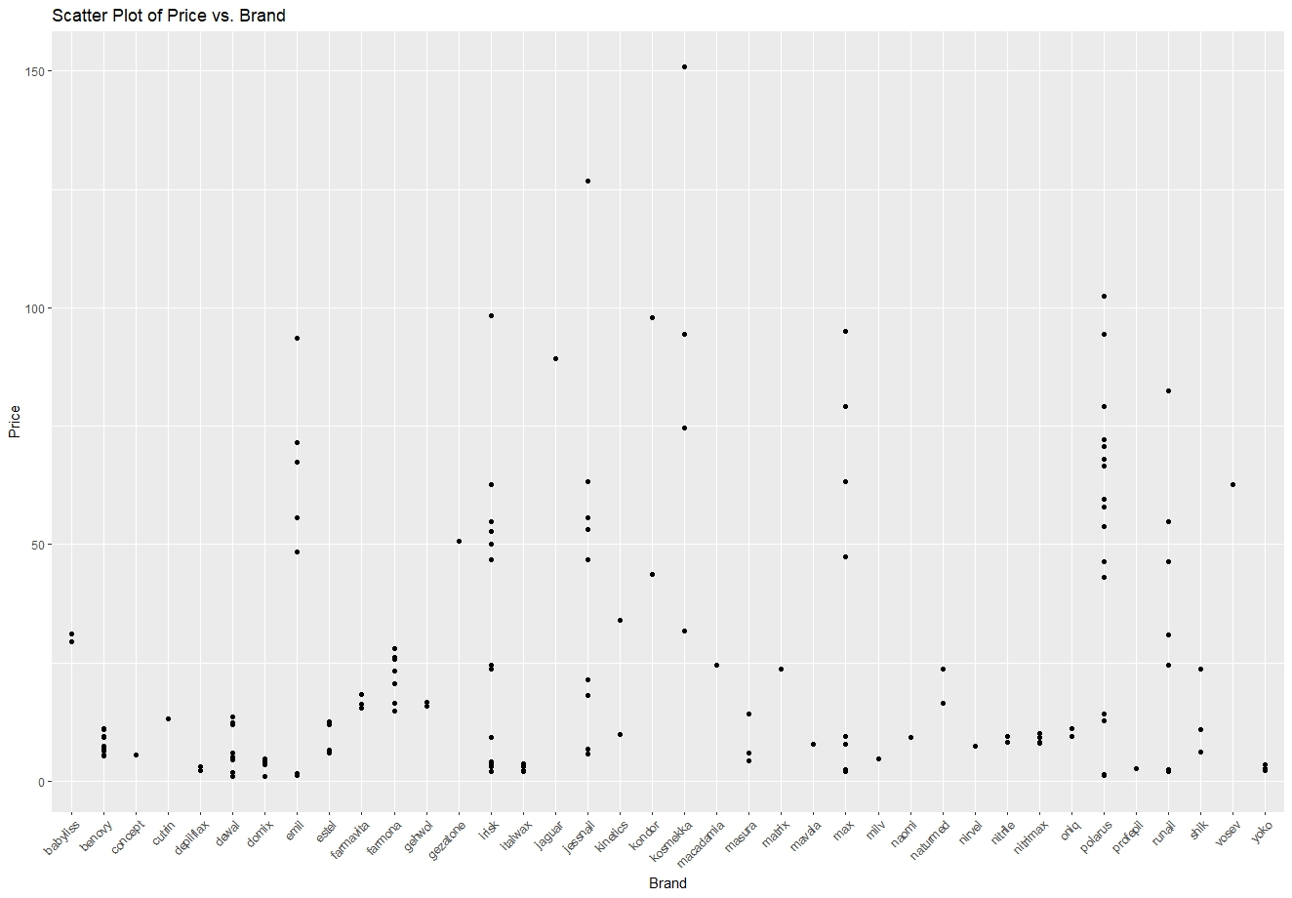

The visualizations you've shared seem to represent various data analyses such as price distributions, brand comparisons, event type breakdowns, and market share amongst categories. While I can't view these images directly, these types of charts are typically used to extract insights such as the most common price points for products, which brands are most prevalent or have the widest price ranges, the most frequent types of customer-product interactions, and how market share is distributed across different categories or brands. This information is crucial for understanding consumer behavior, product performance, and market dynamics, which can inform strategic business decisions.

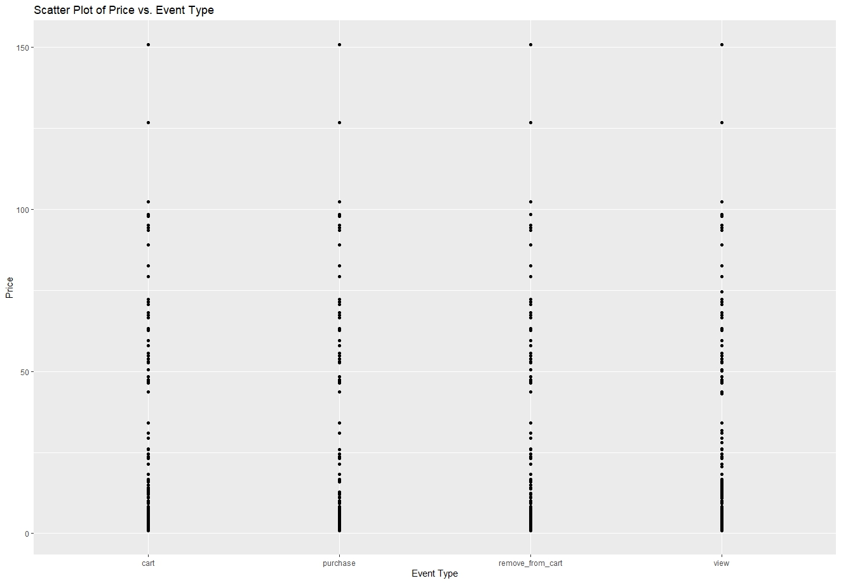

The visualization seems to be a scatter plot of price versus event type. This type of chart typically shows the relationship between a continuous variable (price) and a categorical variable (event type). From the chart, one could infer the distribution and range of prices associated with different types of events such as adding to cart, purchasing, removing from cart, or viewing. If there are outliers or clusters, these could indicate common price points or rare, unusual pricing strategies for certain events. It can also show the variability in pricing for each event type, which can be useful for understanding consumer behavior and pricing strategies.

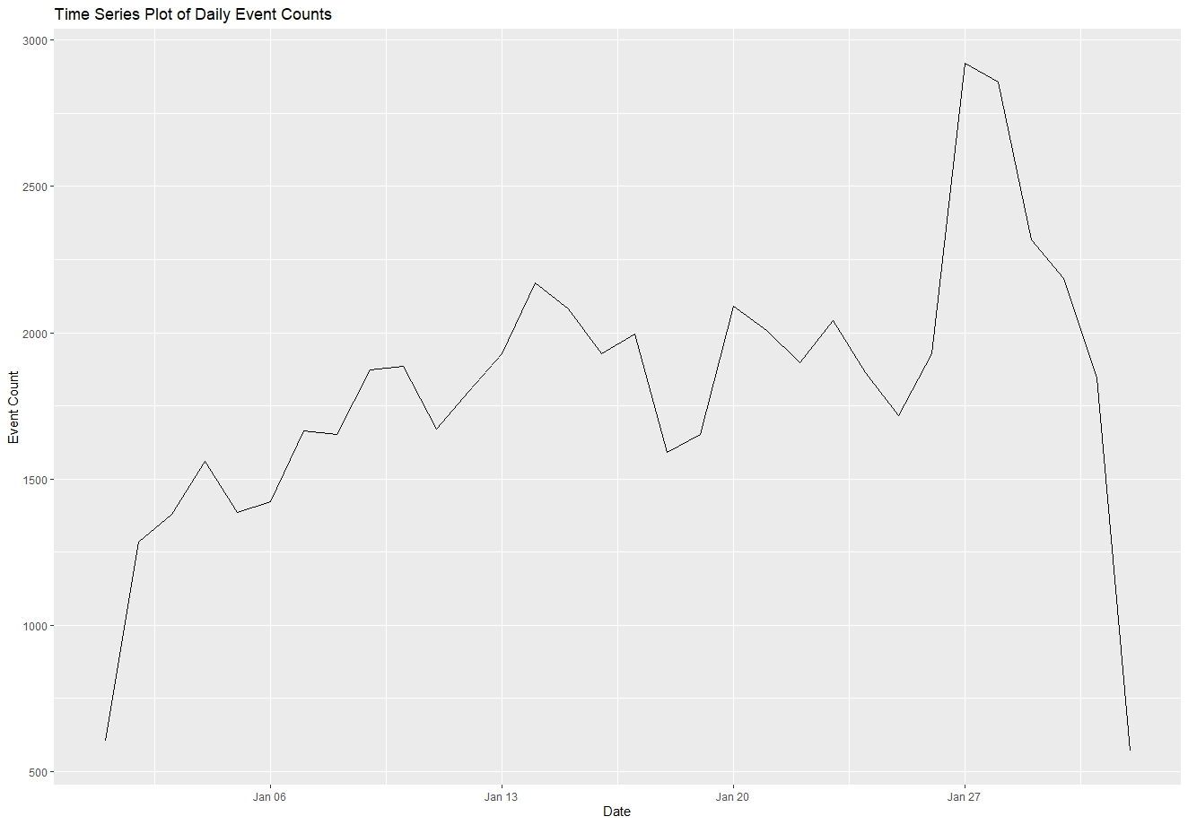

The time series graph of daily event counts depicts fluctuations over a period, likely representing the volume of interactions or transactions over time. The data points show peaks and troughs, indicating variability in the daily counts. A significant rise or drop could correspond to specific events or changes in user behavior, promotions, stock availability, or other external factors. The sharp decline at the end may suggest a data cut-off, a system issue, or a drastic reduction in events. This graph is useful for understanding trends, planning inventory, and strategic decision-making related to business operations.

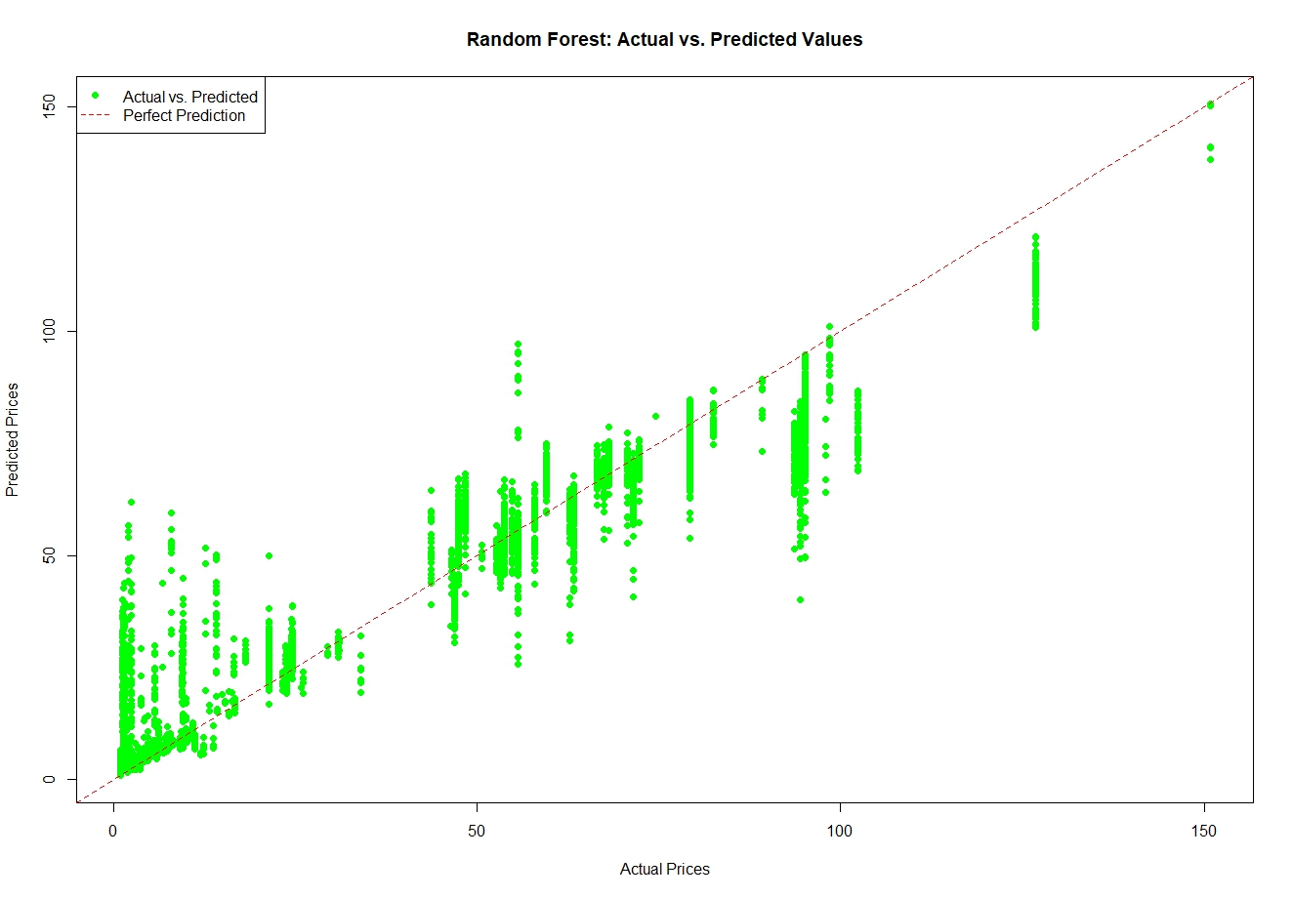

The graph titled "Random Forest: Actual vs. Predicted Values" likely shows the results of a Random Forest regression model, comparing the predicted values against the actual values of prices. The green dots represent the price predictions for each data point, and the dashed line indicates the line of perfect prediction where actual prices equal predicted prices. The closer the dots are to this line, the more accurate the predictions. If the dots are widely spread or far from the line, this indicates a variance between the predicted and actual values, suggesting a less accurate model. The spread of the dots might also reveal patterns or trends in the model's performance across different price ranges.

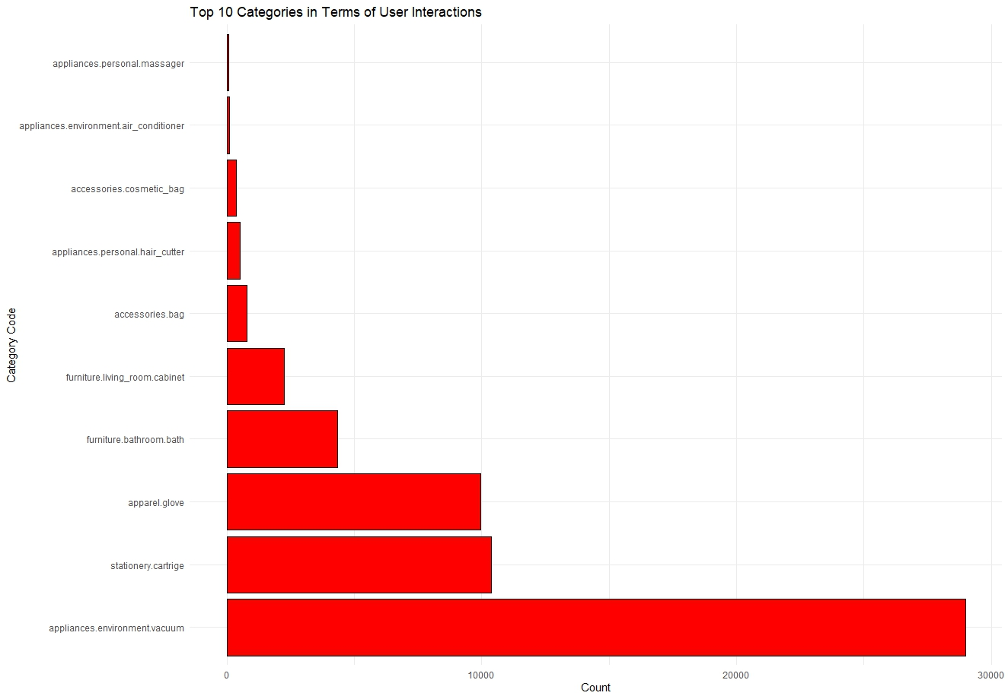

From the provided graph "Top 10 categories in terms of user interactions," we can infer that the category with the highest user interactions is 'appliances.environment.vacuum,' which indicates a strong consumer engagement or interest in vacuum cleaners. The next categories, including 'stationery.cartridge,' 'apparel.glove,' and 'furniture.bathroom.bath,' suggest a varied range of products that attract user interactions. The visual suggests that user interaction is not evenly distributed across categories; certain categories like personal massagers, air conditioners, and hair cutters also feature, but with fewer interactions than vacuums. This could indicate market trends, popularity, or seasonality effects in consumer behavior.

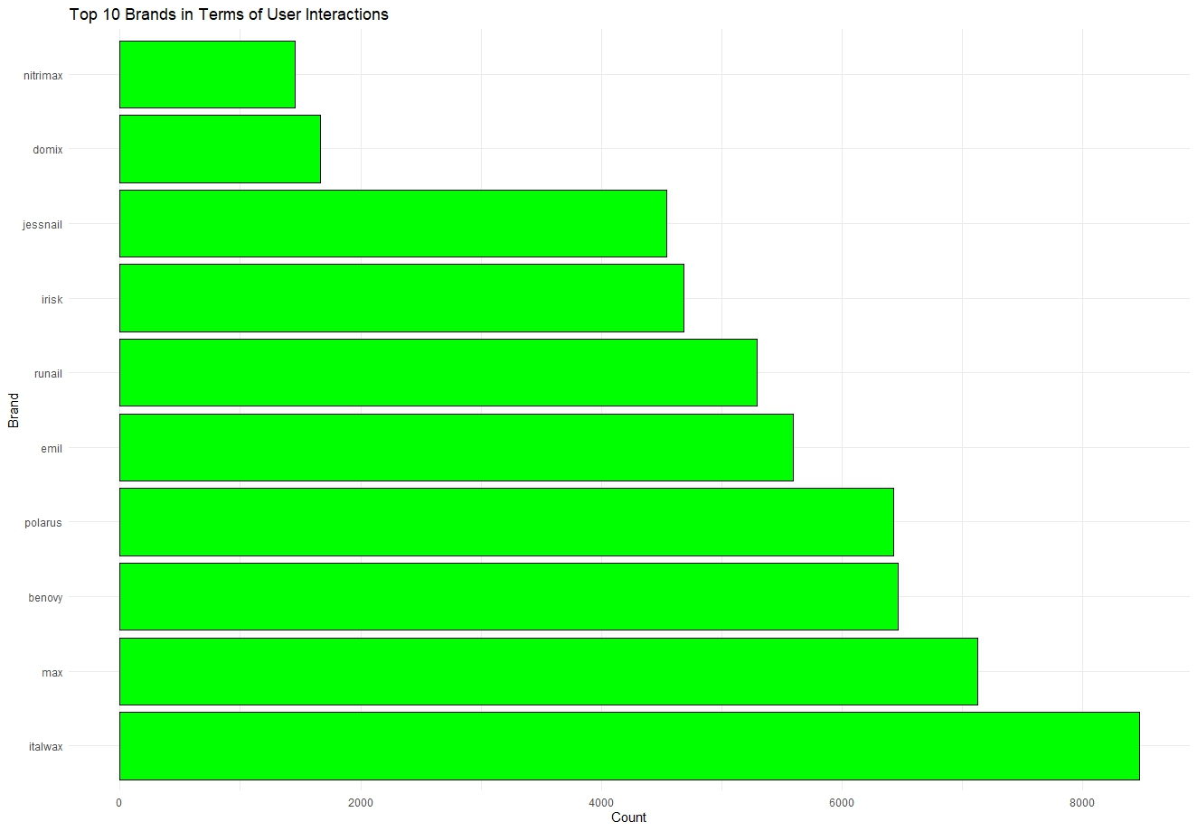

The graph titled "Top 10 Brands in Terms of User Interactions" likely displays the number of interactions users have had with products from different brands. The 'user interactions' could include various actions such as views, clicks, purchases, or reviews. The brands are listed on the y-axis, and the count of interactions is represented on the x-axis. The graph's purpose is to rank the brands by the level of engagement or interaction they receive from users, with higher bars indicating more interactions. This kind of analysis is useful for understanding which brands are most popular or engaging in a given dataset or within a certain market segment.’

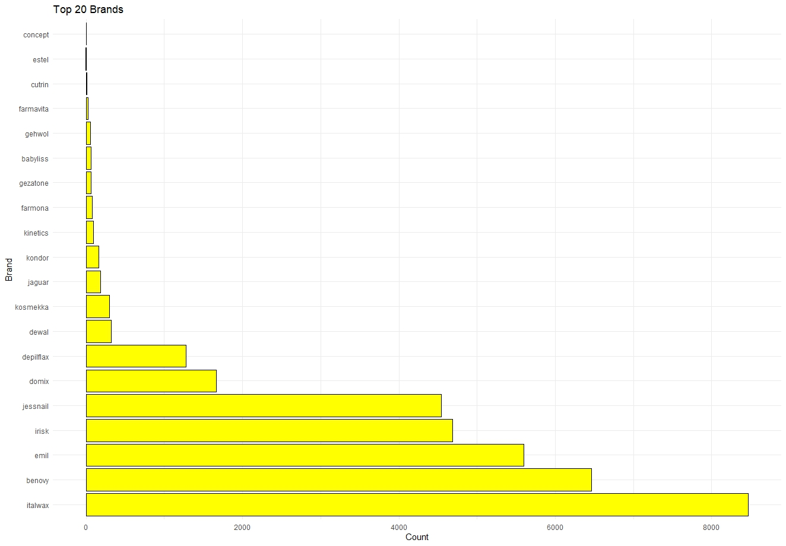

This bar chart shows the top 20 brands based on the number of user interactions. Each bar represents a brand and its corresponding count, indicating the level of engagement or popularity among users within the dataset. The lengths of the bars are directly proportional to the counts; thus, a longer bar indicates a higher number of interactions. This type of visualization is helpful for quickly identifying which brands are most engaged with by users, which can be valuable for market analysis, strategic planning, or inventory management. It seems the brand at the top has significantly more interactions than the others, suggesting it is a market leader within this dataset.

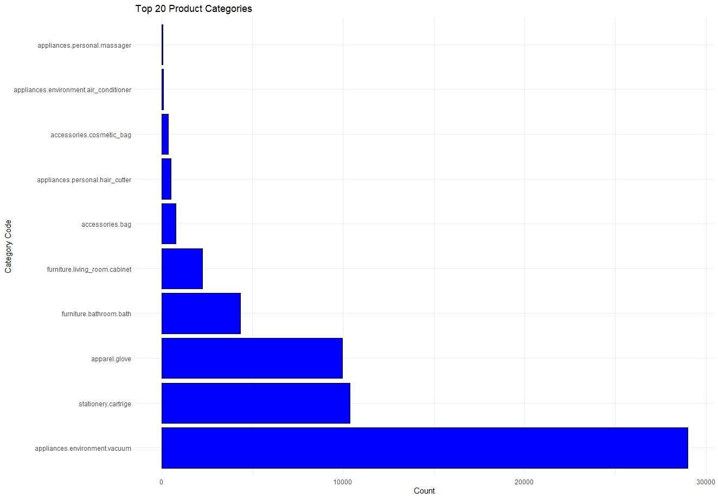

The visualization depicting the top 20 product categories shows the count of user interactions per category. The horizontal bars represent different product categories labeled by their category codes, and the length of each bar reflects the count of interactions, such as views, purchases, or cart additions. From such a graph, one can infer the relative popularity or consumer demand for these categories. A longer bar indicates a higher count of interactions, suggesting that those items are more frequently browsed, considered, or purchased by users, revealing consumer interest and market trends within the dataset.

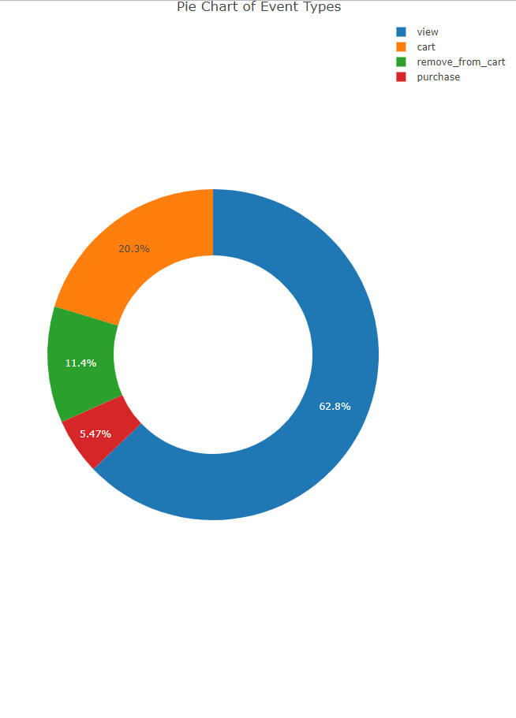

The pie chart visualizes the distribution of different types of events, likely from a dataset tracking user interactions such as views, adding to cart, removing from cart, and purchases. The largest segment, occupying the majority of the chart, indicates that 'view' events are the most frequent, suggesting that users are viewing products significantly more than engaging in other actions. The 'cart' events form the second-largest segment, followed by 'purchase' and 'remove_from_cart' events, respectively. This hierarchy indicates user behavior funnel, with many initial views, some interest as indicated by cart additions, and finally, the actual conversions reflected in purchases. The 'remove_from_cart' actions are the least, which could either suggest high purchase intent once items are in the cart or less frequent reconsideration of cart contents.